


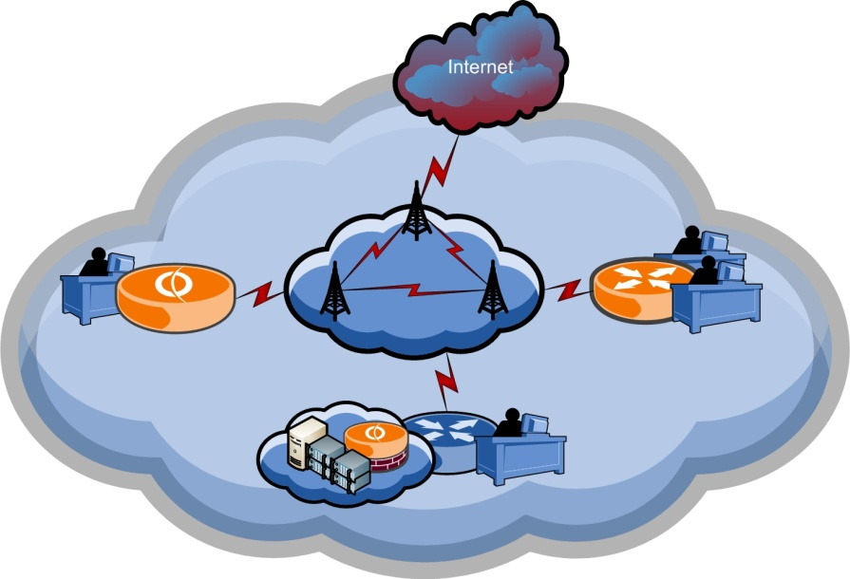

Wireless Broadband Internet product (FW-INET), enables all the web services you need – voice, data, text, and video.
Chose from among FW-INET packages, to get the one that is right for you.

Features
• FW-INET products can be set up in your home or office in minutes.
• Use FW-INET high-speed connections for quick response and fast download without borders, no download limits in our packages.
• Take it anywhere in your coverage area.
Complete Wireless Broadband Solutions
With us you will never be in need for technical support!
Our complete wireless broadband solution can cover you wherever you were; flawlessly and seamlessly, just set it and forget it.
925 Karrada,
Baghdad, IRAQ
Tel: +964 770 800 0046
Fax: +9641 778 2811
Email: info@future-waves.com
Website: www.future-waves.com
Wireless Broadband Internet
FW-INET-64
Our standard Internet service provides reliable wireless connectivity any time. There is no download limits applied on all of our packages, unlike other service providers.
FW-INET-128
Our premium residential service gives the transmission speed and features needed for home businesses and residential customers using our high quality wireless Internet services.
FW-INET-256
This is our Internet package for businesses further extends transmission speed and high quality features to enable the business services you need.
FW-INET-512
This larger businesses package is the ideal choice for smaller Internet service provider, it provides unlimited business feature all along with uncompetitive process.
FW-INET-ENTERPRISE
Avoid the administration and expenses of VSAT and get the speed you require, chose transmission speed up to 20 Mbps.
How to buy?
You can buy by different ways, you can call our office, or send email to info@future-waves.com, or you are welcome to visit us in our
office, so we can help you chose the right service for your business.
HOW IT WORKS
Basically, we have a full featured wireless infrastructure.
We will connect you wirelessly to our main station where you will get a full connectivity to the Internet.
As we tell, we cover all your requirement, so you will be assigned one public IP address if you have a basic set up, you will now be allowed more than on public IP address.
If your business requires a range of public IP addresses, then we will have more advanced set up, with involvement of routing solution you will be set a range of public IP addresses.
As many IP addresses as you want, you can get, so as much bandwidth as you require.
You will be part of our infrastructure once you get connected, so you will have full access to our feature once they are activated as per your request, all voice and data connectivity will be available.
Please, for more information visit our web site.
CUSTOM SOLUTIONS
Custom solutions for special business, you can send us an email, or visit our office so we can understand your requirement, to build customized services as your business require.

WEB SOLUTIONS
We have a wide range of different web solutions, starting from email hosting to web hosting services as you require. There is no need to get involved into the IT complications, leave the hard work for us.

WORLD-CLASS SUPPORT
You will not require any technical support, due to the flawlessly nature of our services. Yet, if you need any help to improve your IT business, you will find our highly trained staff listening.

IT solutions that work for your business.
We can customize solutions for you as you require.

We have a wide variety of customization ways for the services
to meet your requirements, Internet is in your hands.

package choices
• FW-inet-64
• fw-inet-128
• fw-inet-256
• fw-inet-512
• fw-inet-enterprise

